Escape:

An optimization method based on crowd evacuation behaviors

Kaichen OuYangª, Shengwei Fu^{b}, Yi Chen^{c}, Qifeng Cai^{d}, Ali Asghar Heidari^{e}, Huiling Chen^{c,*}

ªDepartment of Mathematics, University of Science and Technology of China, Hefei 230026, China
oykc@mail.ustc.edu.cn
^{b}Key Laboratory of Advanced Manufacturing Technology, Ministry of Education, Guizhou University, Guiyang, Guizhou 550025, China
shengwei_fu@163.com
^{c}Department of Computer Science, Wenzhou University, Wenzhou 325035, China
kenyoncy2016@gmail.com, chenhuiling.jlu@gmail.com, chenhuiling_jsj@wzu.edu.cn
^{d}Department of Physics, University of Science and Technology of China, Hefei 230026, China
qifengcai@mail.ustc.edu.cn
^{e}School of Surveying and Geospatial Engineering, College of Engineering, University of Tehran, Tehran, Iran
as_heidari@ut.ac.ir

* Corresponding author: Huiling Chen (chenhuiling.jlu@gmail.com)

Abstract: Meta-heuristic algorithms, particularly those based on swarm intelligence, are highly effective for solving black-box optimization problems. However, maintaining a balance between exploration and exploitation within these algorithms remains a significant challenge. This paper introduces a useful algorithm, called Escape or Escape Algorithm (ESC), inspired by crowd evacuation behavior, to solve real-world cases and benchmark problems. The ESC algorithm simulates the behavior of crowds during the evacuation, where the population is divided into calm, herding, and panic groups during the exploration phase, reflecting different levels of decision-making and emotional states. Calm individuals guide the crowd toward safety, herding individuals imitate others in less secure areas, and panic individuals make volatile decisions in the most dangerous zones. As the algorithm transitions into the exploitation phase, the population converges toward optimal solutions, akin to finding the safest exit. The effectiveness of the ESC algorithm is validated on two adjustable problem size test suites, CEC 2017 and CEC 2022. ESC ranked first in the 10-dimensional, 30-dimensional tests of CEC 2017, and the 10-dimensional and 20-dimensional tests of CEC 2022, and second in the 50-dimensional and 100-dimensional tests of CEC 2017. Additionally, ESC performed exceptionally well, ranking first in the engineering problems of pressure vessel design, tension/compression spring design, and rolling element bearing design, as well as in two 3D UAV path planning problems, demonstrating its efficiency in solving real-world complex problems, particularly complex problems like 3D UAV path planning. Compared with 12 other high-performance, classical, and advanced algorithms, ESC exhibited superior performance in complex optimization problems. The source codes of ESC algorithm will be shared at https://aliasgharheidari.com/ESC.html and other websites.

Keywords: Swarm intelligence, Crowd behavior, Escape Algorithm (ESC), Engineering optimization, 3D UAV path planning

Escape Algorithm (ESC)
ESC is inspired by how people behave during emergency evacuations. This section explains the background of crowd evacuation systems and how these behaviors inspired the design of the ESC algorithm. By modeling the different responses—calm, herding, and panic—of individuals in a crowd, the ESC algorithm effectively balances exploration and exploitation in solving complex optimization problems.

3.1 Inspiration
In this section, we will introduce the crowd evacuation system's research background and explain the Escape algorithm's inspiration source.
The development of the ESC draws profound inspiration from the nuanced dynamics of human behavior during emergency evacuations[54]. In the chaotic backdrop of emergency scenarios—ranging from natural disasters to human-induced threats—individuals exhibit a spectrum of behaviors influenced by panic, environmental conditions, and the collective movement of the crowd [55-57]. These behaviors significantly impact the efficiency of evacuation processes, highlighting the importance of adaptive and strategic planning. Our algorithm encapsulates this complexity through a computational lens, translating the observed human behaviors into a meta-heuristic framework to solve optimization problems.
The ESC algorithm is particularly inspired by the "leader-follower" system[58, 59] observed in crowds, where individuals naturally assume roles that guide the collective movement. In this system, leaders (both static and dynamic) emerge to influence the direction and pace of the evacuation, while followers form the bulk of the crowd, their movement influenced by those around them. This phenomenon is mirrored in our algorithm through the division of agents into calm, herding, and panic crowd[60] in the exploration phase of the algorithm, each exhibiting distinct behaviors that collectively drive the search process towards optimal solutions.
- Calm crowd: The calm individuals in a crowd, who assess situations with a clear mind and make rational decisions. These agents methodically search the problem space, akin to calm individuals finding efficient paths in an evacuation, guiding others through their steady influence.
- Herding crowd: The herding behavior, where individuals follow the crowd without clear personal direction, is mirrored in the conforming agents of our algorithm. This behavior enhances the exploitation phase, as agents converge on promising areas of the search space, similar to how individuals in a crowd might follow others to perceived exits or safe areas.
- Panic crowd: The panic-stricken individuals, whose unpredictable and erratic movements can both hinder and unexpectedly aid in finding escape routes, inspire the diversification mechanisms in our algorithm. Their behavior is replicated in the panic agents, introducing randomness and preventing premature convergence to local optima, akin to how panic in a crowd can lead to discovering unconventional exits.
Through the ESC algorithm, we harness the intrinsic wisdom of crowd behavior during emergencies, translating the interplay of calm, herding, and panic into a computational model. This approach not only offers a useful perspective on algorithm design but also underscores the potential of natural and human phenomena as sources of inspiration for developing advanced problem-solving strategies.

3.2 Algorithm and Population Initialization
ESC is designed to simulate crowd behavior during emergency evacuations, where individuals must navigate toward exits in a dynamic and uncertain environment. The ESC introduces the concept of an Elite Pool, representing the best-performing individuals who symbolize potential exits identified by the crowd. This mechanism enhances the algorithm’s ability to explore the solution space thoroughly, avoiding local optima by simultaneously considering multiple directions.
The ESC algorithm begins by initializing a population of $N$ individuals, each described by a $D$-dimensional vector $x_{i}=\left(x_{i,1},x_{i,2}…,x_{i,D}\right)$ The value of the $j−th$ dimension for the $i−th$ individual is given by:
$x_{i,j}=lb_{j}+r_{i,j}×\left(ub_{j}−lb_{j}\right),r_{i,j} U\left(0,1\right)$ (1)
Here,${lb}_{j}$ and ${ub}_{j}$ represent the lower and upper bounds of the $j−th$ dimension, ensuring that each individual’s initial position is randomly distributed within the feasible space. The random variable $r_{i,j}$ is uniformly distributed between 0 and 1, reflecting the randomness in the initial cdecision-making process during an evacuation.
After initializing the population, the fitness of each individual $f_{i}=f\left(x_{i}\right)$ is evaluated using a fitness function $f$.The population is then sorted by fitness in ascending order, and the top individuals are stored in the Elite Pool $E$as Eq. (2), the parameter that represents the number of potential safety exits found by the crowd.
$E=\{x_{\left(1\right)},x_{\left(2\right)},…,x_{}$ (2)
These elite individuals represent the best potential solutions (exits) identified by the population and serve as reference points for subsequent iterations.

3.3 Panic Index and Iterative Process
The ESC algorithm models the iterative process to reflect the evolving behavior of the crowd as the evacuation progresses. The algorithm adjusts individual movements based on their classification into calm, conforming, or panic groups, corresponding to different behavioral responses during an evacuation.
At the start of each iteration $t$, the panic index $P\left(t\right)$ is calculated as follows:
$P\left(t\right)=cos\left(\frac{πt}{\text{6T}}\right)$ (3)
The panic index reflects the overall level of panic in the crowd, with higher values indicating more chaotic behavior. This index decreases over time as $t$ goes from 0 to the number of iterations $T$, simulating the crowd’s adaptation to the evacuation environment.

3.4 Exploration Phase
During the exploration phase, when $t≤\frac{T}{2}$ (T is the maximum number of iterations of the algorithm, and t is the current number of iterations), the population is divided into calm, conforming, and panic groups based on their fitness levels. Specifically, the population is sorted in ascending order of fitness, and individuals are stratified into three groups according to the proportions,$c=0.15$,$h=0.35$,and $p=0.5$ for the calm, conforming, and panic groups, respectively. This stratification reflects the varied responses of individuals in a crowd during an evacuation, where some remain calm, others conform to the group's behavior, and some panic.

3.4.1 Calm Group Update
Individuals in the calm group behave rationally, moving toward a central position $C_{j}$​, which represents the collective decision of the group:
$x_{i,j}^{\text{new}}=x_{i,j}+m_{1}×\left(w_{1}×\left(C_{j}−x_{i,j}\right)+v_{c,j}\right)×P\left(t\right)$ (4)
Here,$C_{j}$is the center of the calm group in the $j−th$ dimension, calculated as the mean of all calm individuals in that dimension. The vector $v_{c,j}$ is defined as Eq. (5), where $R_{c,j}=r_{min,j}^{c}+r_{i,j}×\left(r_{max,j}^{c}−r_{min,j}^{c}\right)$ is a randomly generated position within the calm group’s bounds.$r_{min,j}^{c}∧r_{max,j}^{c}$ represent the minimum and maximum values of the $j−th$ dimension for all individuals in the calm group and $ϵ_{j}=\frac{z_{j}}{50}\left(z_{j} N\left(0,1\right)\right)$represents a slight adjustment in the individual's movement.The binary variable $m_{1}$ is determined by a Bernoulli distribution , allowing for partial updates, which simulates parts of the dimension that are not updated due to crowd congestion. Specifically, $m_{1}$ is generated such that it takes the values 0 or 1 with equal probability. $w_{1}$ is an adaptive Levy weight, calculated using a Levy distribution to simulate the step sizes in the exploration phase, which is defined in section 3.6. Fig 2 shows the updating process of the calm group.
$v_{c,j}=R_{c,j}−x_{i,j}+ϵ_{j}$ (5)
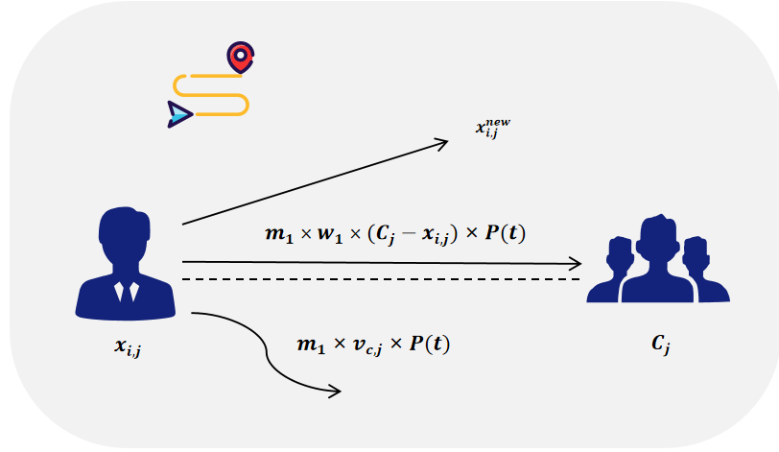
Fig. 2 Updated schematic of the Calm Group

3.4.2 Herding Group Update
Herding individuals follow the behavior of both the calm and panic groups. Their positions are updated based on influences from both:
$x_{i,j}^{\text{new}}=x_{i,j}+m_{1}×\left(w_{1}×\left(C_{j}−x_{i,j}\right)+m_{2}×w_{2}×\left(x_{p,j}−x_{i,j}\right)+v_{h,j}×P\left(t\right)\right)$ (6)
In this equation,$x_{p,j}$is a randomly selected individual from the panic group, representing a potential direction of panic-driven movement.$w_{2}$is another adaptive Levy weight used for the conforming group, which is defined in section 3.6. The vector$v_{h,j}$is defined as Eq. (7), where $R_{h,j}=r_{min,j}^{h}+r_{i,j}×\left(r_{max,j}^{h}−r_{min,j}^{h}\right)$ is a randomly generated position within the herding group’s bounds. The $r_{min,j}^{h}∧r_{max,j}^{h}$ represent the minimum and maximum values of the $j−th$ dimension for all individuals in the herding group and the $m_{2}$ is a binary variable which is generated through the same mechanism as $m_{1}$. Fig 3 shows the updating process of the herding group.
$v_{h,j}=R_{h,j}−x_{i,j}+ϵ_{j}$ (7)
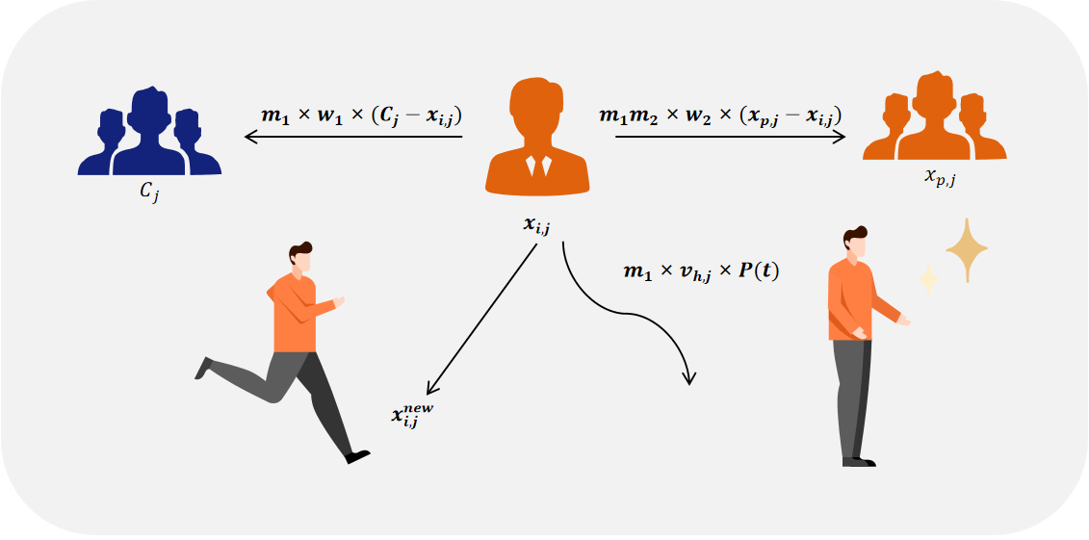
Fig. 3 Updated schematic of the herding crowd

3.4.3 Panic Group Update
Panic-driven individuals explore the solution space more erratically, influenced by potential exits (from the Elite Pool) and random directions from other individuals:
$x_{i,j}^{\text{new}}=x_{i,j}+m_{1}×\left(w_{1}×\left(E_{j}−x_{i,j}\right)+m_{2}×w_{2}×\left(x_{\text{rand,}j}−x_{i,j}\right)+v_{p,j}×P\left(t\right)\right)$ (8)
Here,$E_{j}$ is a randomly selected individual from the Elite Pool, representing a possible exit that a panic-driven individual might head toward.$x_{rand,j}$ represents a randomly selected individual from the population, introducing an element of randomness in the panic-driven movement. The vector $v_{h,j}$is defined as Eq. (9), where $R_{p,j}=r_{min,j}^{p}+r_{i,j}×\left(r_{max,j}^{p}−r_{min,j}^{p}\right)$ is a randomly generated position within the panic group’s bounds.$r_{min,j}^{p}∧r_{max,j}^{p}$ represent the minimum and maximum values of the $j−th$ dimension for all individuals in the panic group. Fig 4 shows the updating process of the panic group.

$v_{p,j}=R_{p,j}−x_{i,j}+ϵ_{j}$ (9)
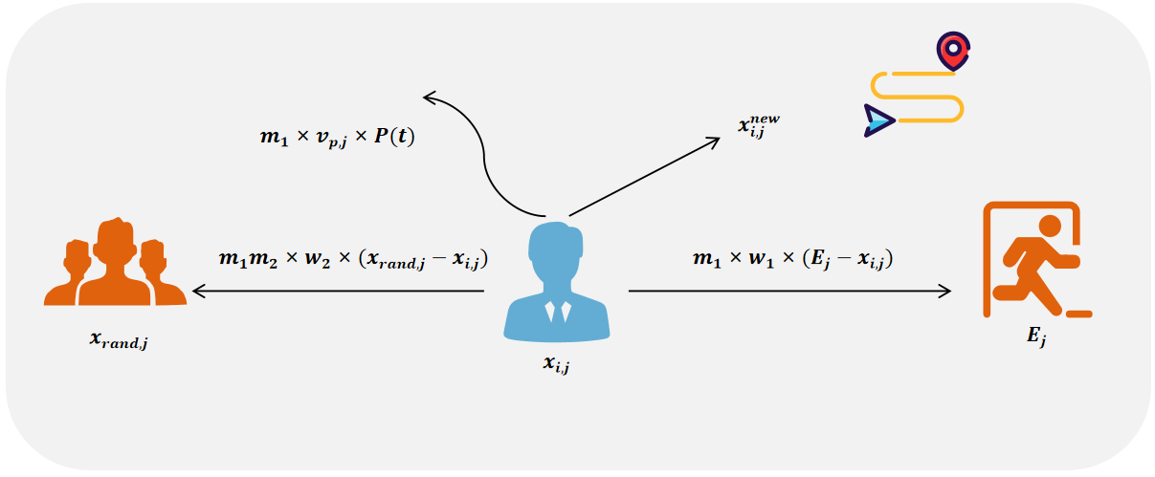
Fig. 4 Panic crowd update schematic

3.5 Exploitation Phase
As the iteration progresses beyond $\frac{T}{2}$, the algorithm transitions into the exploitation phase, where all individuals are considered calm. The focus shifts to fine-tuning positions based on the best solutions identified so far. During this phase, individuals refine their positions by moving closer to members of the Elite Pool, which represents both possible safety exits and the best solutions identified in previous iterations, as well as randomly selected individuals from the population. This process simulates the crowd's gradual convergence towards identified optimal exits. The position update during this phase is given by the Eq. (10).
$x_{i,j}^{new}=x_{i,j}+m_{1}⋅w_{1}⋅\left(E_{j}−x_{i,j}\right)+m_{2}⋅w_{2}⋅\left(x_{\text{rand,}j}−x_{i,j}\right)$ (10)
In Eq. (10),$x_{i,j}$represents the position of the $i−th$ individual in the $j−th$ dimension.$E_{j}$ is the position of a member from the Elite Pool, symbolizing both a possible safety exit and one of the best solutions identified so far. $x_{rand,j}$ is the position of a randomly selected individual from the population. This allows individuals to refine their positions by moving closer to both the Elite Pool members and randomly selected individuals, simulating the crowd’s gradual convergence towards the identified optimal exits. Fig. 5 shows the population update schematic in the exploration phase.
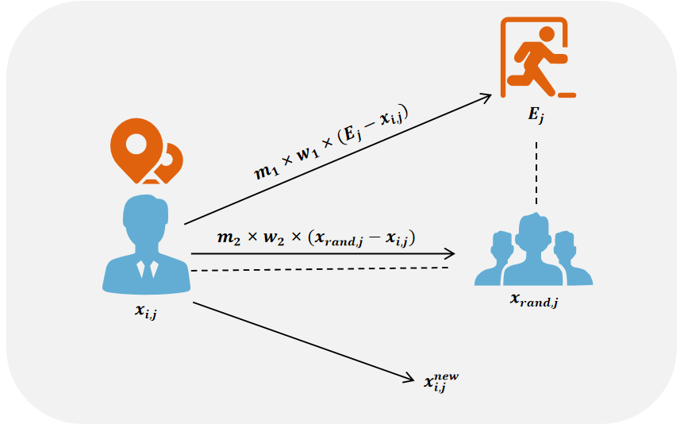
Fig. 5 Population update schematic in the exploration phase

3.6 Adaptive Levy Weights and Behavior Simulation
The step sizes of individuals are controlled by adaptive Levy weights, which simulate varying degrees of exploration and exploitation at different stages of the algorithm. The Levy weight for each dimension j is calculated as Eq. (11)
$w_{j}=u_{j}∨\frac{}{v_{j}{}^{\frac{1}{β}}},u_{j} N\left(0,σ^{2}\right),v_{j} N\left(0,1\right), σ={\left(\frac{Γ\left(\frac{1+β}{2}\right)⋅β⋅2^{\frac{1}{β}−1}}{Γ\left(1+β\right)⋅sin\left(\frac{πβ}{2}\right)}\right)}^{\frac{1}{β}}$ (11)
where $β$ is a parameter that dynamically adjusts as the algorithm progresses as Eq. (12) and $Γ$ is the Gamma function.
$β=β_{\text{base}}+0.5×sin\left(\frac{πt}{\text{2T}}\right)$ (12)
In Eq. (12), $β_{base}$ is the initial value of $β$ , which is same to the empirical setting used in the Harris Hawks Optimization (HHO) [61] algorithm, with a value of 1.5. This adjustment allows the algorithm to initially make larger exploratory moves (when $β$ is smaller) and gradually transition to finer, exploitative moves (as $β$ increases), mirroring the natural progression from panic-driven exploration to calm, rational decision-making in a crowd.

3.7 Fitness Evaluation and Elite Pool Update
At each iteration, the fitness of each updated individual is recalculated. A greedy selection process is used to retain the better solution between the old and new positions:
$f_{i}^{\text{new}}=f\left(x_{i}^{\text{new}}\right)$ (13)
The update rule for each individual can be described as:
$x_{i}=\left\{\begin{matrix}x_{i}^{\text{new}} & \text{if }f_{i}^{\text{new}}<f_{i} \\ x_{i} & \text{otherwise}\end{matrix}\right.$ (14)
If the new fitness $f_{i}^{new}$ is better (i.e., lower for a minimization problem) than the previous fitness $f_{i}$ the individual’s position is updated to $x_{i}^{new}$ . Otherwise, the previous position $x_{i}$ is retained. The Elite Pool $E$ is updated at each iteration to ensure it contains the best solutions found so far. This pool plays a crucial role in guiding the population toward the best exits identified during the simulation.

3.8 Computational Complexity
In this section, we describe the general computational complexity of the ESC (Escape) algorithm. The computational complexity of ESC primarily depends on two components: the initialization of the population and the main iterative process of the algorithm, which includes calculating the fitness functions, sorting, and updating the solutions. Assume that the number of search agents is $N,T$ denotes the maximum number of iterations, and $D$represents the dimensionality of the problem. The computational complexity of initializing the population, where each individual is represented by a $D$-dimensional vector, is $O\left(N×D\right)$ . The fitness evaluation for the entire population also requires $O\left(N×D\right)$ operations. Sorting the population by fitness values is performed using a comparison-based sorting algorithm, which has a complexity of $O\left(N×logN\right)$ . During the main iterative process, the algorithm runs for $T$ iterations. In each iteration, the population is divided into calm, herding, and panic groups, and the positions of individuals in each group are updated according to different rules. The complexity for updating positions is $O\left(N×D\right)$ , and fitness reevaluation adds another $O\left(N×D\right)$ , and fitness reevaluation adds another $O\left(N×logN\right)$ time. Thus, the total complexity per iteration is $O\left(N×D+NlogN\right)$ . Consequently, the overall computational complexity of the ESC algorithm is $O\left(T×N×\left(D+logN\right)\right)$.
Next, we will compare the complexities of the ESC with the Slime Mould Algorithm (SMA)[62] and HHO [61] based on the calculation methods from their original papers. To ensure consistency in our analysis, we merged some computational items when evaluating the complexities of SMA and HHO, in line with their original descriptions. For the SMA algorithm, the overall complexity is $O\left(T×N×\left(D+logN\right)\right)$. This reflects the detailed handling of fitness evaluations and position updates in SMA, as well as the sorting and weight adjustments involved in each iteration. The complexity of the HHO algorithm is $O\left(T×N×D\right)$ , mainly covering initialization, fitness evaluation, and position updates, without significant logarithmic terms. This indicates that the HHO algorithm focuses on direct position updates during each iteration, involving fewer sorting or other complex operations.
Overall, the complexity of the ESC algorithm is $O\left(T×N×\left(D+logN\right)\right)$ , indicating that it performs fitness evaluations and position updates and also includes comparison-based sorting operations in each iteration, potentially making it more effective in handling structured optimization problems. ESC and SMA incorporate additional structured elements like sorting and weight updates, making them particularly suitable for complex optimization environments requiring these operations. Meanwhile, HHO, with its more streamlined iterative update strategy, is better suited for fast response and adaptation in dynamic optimization scenarios. Fig 6 shows the flowchart of ESC.

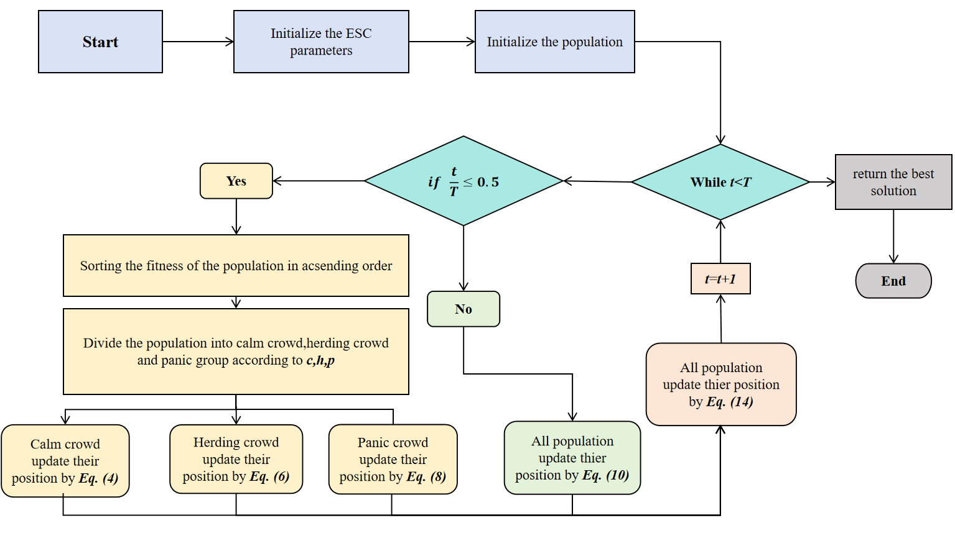
Fig. 6 Flowchart of the escape (ESC) algorithm
Algorithm 1. Pseudocode of escape optimization algorithm (ESC)
1: Initialize ESC parameters
2: Initialize Population:
3: for each individual x_{i} do
4: for each dimension j do
5: Set x_{i,j} = lb_{j} + r_{j} × (ub_{j} − lb_{j} ) where r_{j} ∼ U (0, 1)
6: end for
7: end for
8: Evaluate fitness of each individual fi = f (x_{i})
9: Sort population by fitness in ascending order
10: Store the top eliteSize individuals in the Elite Pool:
E = {x₁, x₂, . . . , x_{eliteSize}}
11: while t ≤ T do
12: if t/T ≤ 0.5 then
13: Compute Panic Index P (t) = cos (πt/6T)
14: Sort population by fitness
15: Divide population into: Calm group (proportion c), Conforming group (proportion h), and
Panic group (proportion p)
16: Update Calm Group using Eq. (4)
17: Update Conforming Group using Eq. (6)
18: Update Panic Group using Eq. (8)
19: else
20: ► Enter exploitation phase
21: Update population using Eq. (10)
22: end if
23: Evaluate the fitness of each individual
24: Apply greedy selection (Eq. 12)
25: Update Elite Pool with best solutions found
26: t = t + 1
27: end while
28: Return Best Solutions from Elite Pool

